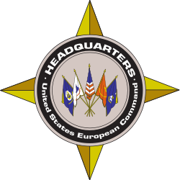
USEUCOM Public Affairs Fact Sheet

U.S. European Command (USEUCOM) Public Affairs
Phone: +49 (0) 711-7080-8147
Email: eucom.media@mail.mil

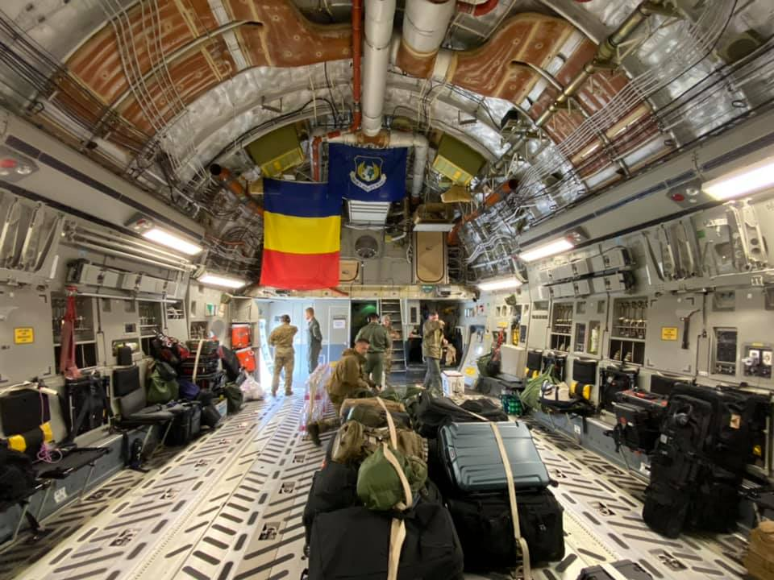
U.S. European Command’s Response to COVID-19
Health Protection
“We've implemented prudent measures to reduce the exposure and transmission of the coronavirus to or from our forces, family members and home stations.”
– U.S. European Commander Gen. Tod Wolters
- The health of the force across U.S. European Command’s area of responsibility is a top priority.
- USEUCOM is well-coordinated with our local host-nation partners to comply with local preventive measures.
- USEUCOM is leveraging the command’s website, social media platforms and other venues to keep military, civilian personnel and their family members informed.
- Installations, components and headquarters leadership continue to conduct virtual town hall meetings to maintain open lines of communication with the force and families.
The Heavy Airlift Wing based out of Pápa Air Base, Hungary, recently assisted with the international Strategic Airlift Capability mission to deliver medical and personal protective equipment to Romania.
- USEUCOM has modified or canceled a wide range of activities and services to slow the spread of this virus.

Assistance to Allies and Partners
“With our allies and partners, we continue to take the necessary steps to reduce the further spread of the virus.” – Gen. Wolters
- July 3, 2020: The U.S. Embassy-Rome's Office of Defense Cooperation, working in close coordination with USEUCOM, delivered 2,000 protective suits to the Italian Civil Protection agency to safeguard frontline workers battling COVID-19.
- July 1, 2020: A donation of face masks and thermometers was delivered to San Marino’s National Public Hospital. Surrounded by Italy and said to be the world’s oldest surviving republic, San Marino’s hospital serves as the sole COVID-19 treatment facility in the micro state.
- June 26, 2020: Personal Protective Equipment and critical cleaning and disinfecting supplies were donated and delivered to the Sarajevo International Airport.
- June 25, 2020: In Italy’s Campania Region, $336,000 worth of medical supplies was donated towards the recovery of Italian local communities following the crisis caused by COVID-19.
- June 24, 2020: In North Macedonia’s capital city of Skopje, a new ultrasound machine was donated and delivered to the Clinic for Infectious Diseases. The clinic serves as the country’s primary government-run medical facility to hospitalize and treat COVID-19 positive patients.
- June 17, 2020: A new ultrasound machine was donated and delivered to the city of Gaeta, Italy, to enhance the city’s lifesaving capabilities to treat COVID-19 patients.
- June 16, 2020: In Armenia’s north, infrared thermometers were donated to Lori and Shirak regions' kindergartens to assist in protecting and slowing the spread of COVID-19 among young, school-aged children.
- June 15, 2020: COVID-19 control and prevention equipment, including gloves, masks, protective suits and state-of-the-art ultraviolet disinfection equipment, was delivered to Slovenia’s Civil Protection and Disaster Relief Administration, the country’s lead emergency management agency, to protect its workers as they work to curb the spread of the virus.
- June 11, 2020: In partnership with the U.S. Agency for International Development, EUCOM delivered vital personal protective equipment (PPE) to the Azerbaijan Food Safety Institute to assist in that country’s ongoing fight against COVID-19.
- June 11, 2020: COVID-19 PPE, including gloves, face shields, gowns and masks, was delivered to Kosovo’s Ministry of Health to help protect frontline health care workers fighting the pandemic.
- June 11, 2020: Additional COVID-19 PPE was donated to Georgia’s Ministry of Internally Displaced Persons to assist the country in its ongoing battle against the COVID-19 virus.
- June 10, 2020: Disease prevention supplies were delivered to Belarus’ Ministry of Health to help the country’s health care professionals curb the pandemic’s spread.
- June 4, 2020: To protect military medical teams treating COVID-19 patients in the Belarusian Armed Forces’ central hospital in capital city Minsk, 1,300 N95 respirators and 200 protective goggles were donated.
- May 30, 2020: Nearly 23,000 pairs of disposable latex gloves and 1,000 liters of hand sanitizer were donated to Latvia’s Ministry of Education to protect school children against COVID-19 as students complete year-end academic testing across the Latvia.
- May 26, 2020: Hundreds of liters of disinfectant, 5,000 face masks and other critical medical supplies and equipment was donated to Bosnia-Herzegovina’s Ministry of Health to assist in that country’s COVID-19 fight.
- May 21, 2020: Some 900 COVID-19 test kits were delivered to Bulgaria's Military Medical Academy. Located in capital city Sofia, the academy is one of the country's largest medical treatment facilities in the battle against the coronavirus.
- May 21, 2020: Protective face shields, produced in Slovenia and funded by USEUCOM, were donated to medical professionals in elder care homes in capital city Ljubljana and towns across Slovenia to prevent the further spread of the COVID-19 virus.
- May 19, 2020: Disposable medical gowns, protective suits and infrared thermometers were delivered to Georgia’s Ministry of Interior Affairs to equip the country’s law enforcement officers.
- May 19, 2020: A full array of PPE, including biological protective suits, respirators, infrared thermometers, protective face shields and eyewear, surgical masks and gloves, was delivered to Moldova’s Hospital for the Ministry of Defense, a central treatment center for citizens testing COVID-19 positive.
- May 18, 2020: To help Greece in its continued COVID-19 fight, personal protective equipment was delivered to the Hellenic National Police to help protect that force as it continues its civil protection mission.
- May 15, 2020: Nearly 4,000 liters of hand and surface sanitizer were delivered to Latvia’s State Emergency Medical Service for use in the country’s mobile COVID-19 testing facilities, dispatch centers and emergency vehicles.
- May 13, 2020: Medical and other relief supplies were flown between Italian supply hubs in Milan and Rome by Ramstein Air Base, Germany-based 86th Airlift Wing to help Italian agencies in the country’s continued battle against COVID-19.
- May 6, 2020: Critical personal protective equipment – from disposable gloves, respirator masks and sets of PPE -- was delivered to Armenia’s Ministry of Emergency Situations to support the country’s efforts to combat COVID-19.
- May 1, 2020: A supply of PPE was delivered to the Ministry of Internally Displaced Persons (IDPs) from the Occupied Territories, Labor, Health and Social Affairs of Georgia to help that government agency fight COVID-19.
- April 28, 2020: Bosnia and Herzegovina’s law enforcement agencies received rapid assistance from the U.S. military and NATO with personal protective equipment to safeguard law enforcement officers from COVID-19 during the course of their duties.
- April 28, 2020: U.S. provided medical personal protective equipment assistance to the central hospital in Montenegro’s capital and largest city, Podgorica.
- April 23 & 27, 2020: USEUCOM donated medical items including respirators, protection suits and other personal protective equipment to the Republic of Moldova.
- April 23, 2020: USAID announces programs that will include: (1) $10 million for essential health commodities; (2) $30 million for Civil Society and non-governmental partners; and (3) $10 million to enable Italian businesses to engage in research, development or manufacturing of therapeutics, vaccines and medical supplies in the fight against COVID-19.
- April 20, 2020: U.S. Defense Department announces America’s package to Italy, providing humanitarian aid and relief services to assist the Italians and their frontline responders combat COVID-19.
- April 15 & 18, 2020: U.S. donated U.S. Defense Department’s Overseas Humanitarian, Disaster, and Civic Aid (OHDACA) funded medical personal protective equipment to North Macedonia.
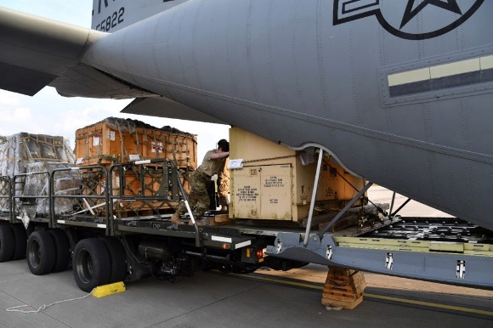
- April 14, 2020: The Office of Defense Cooperation in Lithuania coordinated the donation of U.S. Defense Department’s OHDACA funded critically-needed medical personal protection equipment to the Lithuanian Health Emergency Situation Centre.
- April 14, 2020: The U.S. military and NATO delivered U.S. Defense Department’s OHDACA funded critical medical and disinfectant supplies to aid Bosnia-Herzegovina.
- April 9, 2020: Participated in the donation of important personal protective equipment to Albania to help the Ministry of Health and Social Protection protect front-line healthcare workers.
- March 26, 2020: The Defense Security Cooperation Agency's Humanitarian Assistance Program in coordination with the U.S. Embassy-Rome provided medical equipment to Italy.
Airmen assigned to the 721st Aerial Port Squadron load pallets of medical supplies onto a C-130J Super Hercules to provide medical support to Italy.
- March 22, 2020: U.S. Air Forces in Europe delivered critically needed En-Route Patient Staging Systems (ERPSS) to Italy’s Aviano Air Base and the Italian Ministry of Defense.

Maintaining Military Readiness
“USEUCOM is maintaining its readiness through adjusted local training and reduction of exercises as necessary.” – Gen. Wolters
- One of the command’s largest planned exercises, DEFENDER-Europe 20 has undergone modifications in light of COVID-19.
- Exercises Dynamic Front, Joint Warfighting Assessment, Saber Strike and Swift Response will no longer be conducted.
- USEUCOM is evaluating the size and scope of modifying remaining exercises, while still maximizing efforts to enhance military readiness to address any crisis or contingency.
- The purpose of Exercise DEFENDER-Europe 20 was to build strategic readiness by deploying a combat-credible force to Europe in support of NATO and the U.S. National Defense Strategy. That objective was met.

Health Information Sharing
“The command is adhering to the Center for Disease Control health protection measures and the United States Secretary of Defense's guidance on health protections and travel restrictions.” – Gen. Wolters

Latest USEUCOM COVID-19 Updates: https://www.eucom.mil/coronavirus

U.S. Defense Department: https://www.defense.gov/Explore/Spotlight/Coronavirus/
- Centers for Disease Control and Prevention: https://www.cdc.gov/coronavirus/2019-ncov/index.html
- World Health Organization: https://www.who.int/health-topics/coronavirus
- National Institutes of Health: https://www.nih.gov/health-information/coronavirus
- European Centre for Disease Prevention and Control: https://www.ecdc.europa.eu/en

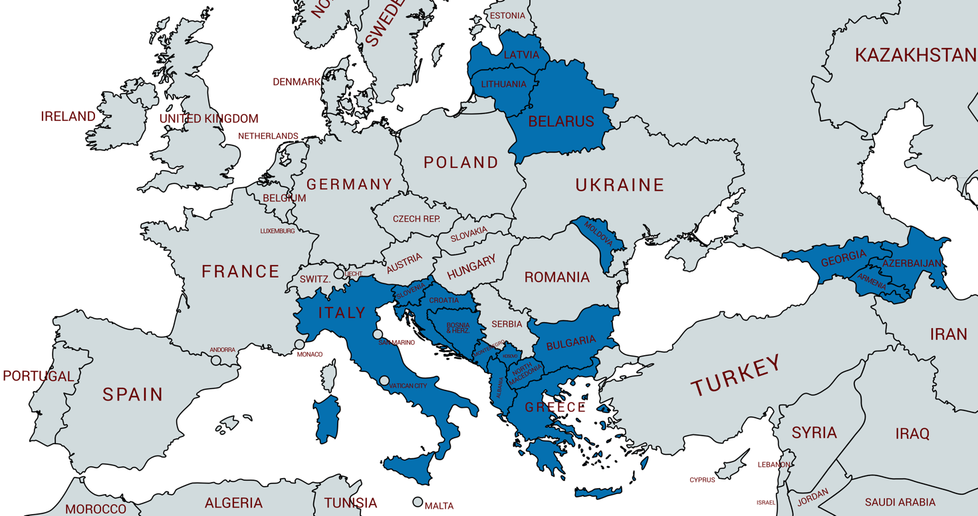
U.S. European Command COVID-19 Delivered Support

