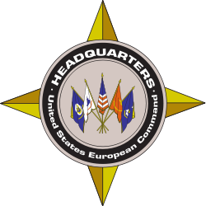
MISO Fact Sheet

U.S. European Command Public Affairs Office
Phone: +49 (0) 711-7080-8147, DSN: 324-412-8147
Email: eucom.media@mail.mil

Program Overview Jan. 24, 2020

U.S. European Command (USEUCOM), in coordination with national, international and regional partners, is conducting Military Information Support Operations (MISO) activities over the next 12 months to support NATO and partner nations. USEUCOM’s MISO activities are predominantly conducted via television, radio or the internet, and may also use print media and face-to-face communication. Other aspects of the program include military-to-military cooperative efforts, supporting military-focused publications, and subject-matter expert exchanges, all of which increase the interoperability and coordination of our military information support efforts with those of our regional partners.

MISO activities are implemented in accordance with U.S. laws and Department of Defense policy in order to support a diversity of voices in the information space, to counter external interference, to build partner-nation capacity, and to assist partner-nation counter-terror operations, counter-recruitment efforts, and counter-radicalization programs. MISO activities are coordinated with U.S. embassies and partner nations to address our shared security concerns within the region.

These MISO activities and military-to-military cooperative efforts will be focused on audiences in the Balkans, the Baltics, western-central Europe, eastern Europe, the Mediterranean region and northern Europe. As needed, MISO efforts will also support activities such as maritime operations, noncombatant evacuations, humanitarian assistance, personnel recovery, and aiding operational efforts in response to instability. MISO activities also support joint training events with our partners throughout the region to more effectively address our shared security concerns and promote best practices.

